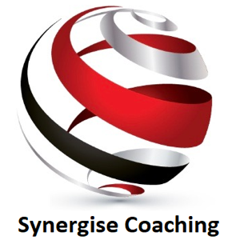
FOUR LONG TERM PROJECTS EXERCISE

Imagine that you're sitting with a trusted friend twelve months from now. You're looking back over the last twelve months, feeling fulfilled that you've worked hard, and that you've made something important happen!

There are no rules or guidelines for these four projects; you can work as hard as you want, you have nothing to lose ... and potentially everything to gain!

PROJECT 1: The Business Project

What new business project could you start today, that would enable you to begin generating a new income for yourself?

Your Ideas:

What am I good at?

What skills do I have?
What Interests me?

What do I need to learn?

My Business
Project

What do I know? Who can help me?

What can I offer That other people need?
What's my first step?

PROJECT 2: The 'Make A Difference' Project 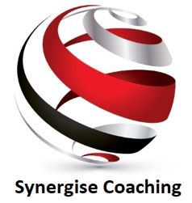

Begin a new 'make a difference' project that will make a huge difference for someone, some people, something or somewhere that you are passionate about:

Your Ideas:

What am I good at?

What skills do I have?
What Interests me?

What am I passionate about?

My Make a
Difference
Project

What do I know? Who Can help me?

What can I offer that other people need?
What's my first step?

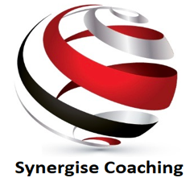
PROJECT 3: The Family Project

Initiate a new project that will either benefit your family, someone else's family, or a community of people that you are passionate about.

Your Ideas:

What am I good at?

What can I share?
With others?
What interests me?

What am I passionate about?
My Family
Project

What can I do that nobody
else Is currently doing?
Can other people
help we with this?

What can I offer, that other people need?
What's the first step I must take?

PROJECT 4: The 'Scary as Hell' Project

Write down some ideas of something that you'd like to do or achieve over the next 12 months which currently 'scares the hell' out of you.

Your Ideas:

What have I never done before?

What terrifies me?

What Interests me?

What am I passionate about?

My 'Scary as Hell'
Project

Is there something that I have always wanted to Do?
Can other people
help me with this?

How will I feel when
I have achieved this.
What's the first step I must take?

